Indian Institute of Information Technology, Allahabad



PROJECT REPORT

Write 'Xpack' interpreter/compiler which can accept an xml file as input and process it for syntax check.

Submitted By:

Group No: - 6
Members: -
Ashish Kumar Sahu Rit2009002
Akshat Sapra Rit2009008
Sharad Dixit Rit2009010
Mohit Kumar Lal Rit2009014
Abhinav vishwa Rit2009038

Table of Contents

Table of Contents i
1.Introduction 1
Methodology 2
Work Plan 3
Procedure 3
Activity Chart Diagram 5

Introduction

Background
XML stands for "eXtensible Markup Language." It allows you to create your own document markups. Where HTML does a very good job of marking documents for browsers, XML allows you to define any kind of document markup, for example a document that describes a "to do" list for an organizer application. XML is a very structured and convenient format. All those random file formats created to store application data can all be replaced with XML.
1.1.2. XML Parser

A parser is a piece of program that takes a physical representation of some data and converts it into an in-memory form for the program as a whole to use. Parsers are used everywhere in software. An XML Parser is a parser that is designed to read XML and create a way for programs to use XML. There are different types, and each has its advantages. Unless a program simply and blindly copies the whole XML file as a unit, every program must implement or call on an XML parser.

Specific Objectives and Scope of the Project
For handling XML data in an application it usually needs three components,
- A representation of the XML data in C++.
- A parser for reading the data into this representation .
- A writer to write the data back to XML.

The goal of the XML compiler is to generate these three components automatically from the schema of the XML.
Automatically generating the code not only eliminates the boring work of writing the code manually, but also gives some additional flexibility. General improvements in parsing XML or for the data representation classes can be implemented centrally in the code generator and applied to a all generated code at once, without manual intervention.

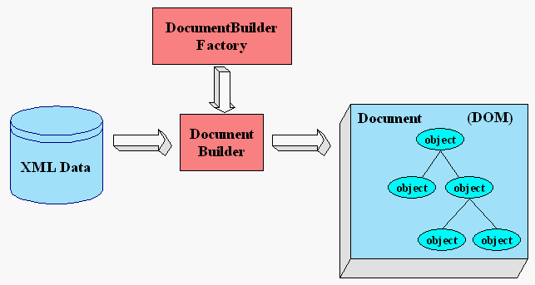
Fig 1: Block Diagram Xml Parser

Methodology

Working with XML Parser
It would be a stream-oriented parser. You register callback (or handler) functions with the parser and then start feeding it the document. As the parser recognizes parts of the document, it will call the appropriate handler for that part (if you've registered one). The document is fed to the parser in pieces, so you can start parsing before you have the whole document. This also allows you to parse really huge documents that won't fit into memory.

Work Plan
The development paradigm of the development is inspired by the modern Rapid Application development(RAD) Model.
Therefore work has been divided in two parts and has been assigned to two different teams.
- 1st Team : (Abhinav Vishwa, Sharad Dixit, Akshat Sapra )
  - Literature Survey( XML related )
  - Introduction to XML
  - XML coding practices for testing puroposes
- 2nd Team : (Mohit Km. Lal, Ashish K. Sahu)
  - Literature Survey( Compilers design related )
  - Introduction to tools necessary in compiler design
  - C coding practices necessary in XML parser design

Procedure
- Problem Identification (1 month).
- Research on LEX and its applications.
- Research on YACC and its applications.
- Research in XML ,syntax, errors.

- Implementation (15-20 days).
- Implementation of the Small segments of the XML Compiler.

- Documentation and Assistance
- Documentation of the whole code.
- Make the read me and directions to use files for the user.

- Testing and Debugging
- Testing and debugging of the whole code after completion.
- Checking the code for some different size of input files in different conditions.

Errors Displayed in final product :
- XML Tags are Case Sensitive
XML elements are defined using XML tags.
XML tags are case sensitive. With XML, the tag <Letter> is different from the tag <letter>.
Opening and closing tags must be written with the same case:

<Message>This is incorrect</message>
<message>This is correct</message>

- XML Elements Must be Properly Nested
In HTML, you might see improperly nested elements:

<b><i>This text is bold and italic</b></i>

In XML, all elements must be properly nested within each other:

<b><i>This text is bold and italic</i></b>

- XML Documents Must Have a Root Element.
XML documents must contain one element that is the parent of all other elements. This element is called the root element.

<root>
<child>
<subchild>.....</subchild>
</child>
</root>

- XML Attribute Values Must be Quoted.
XML elements can have attributes in name/value pairs just like in HTML.
In XML the attribute value must always be quoted. Study the two XML documents below. The first one is incorrect, the second is correct:

<note date=12/11/2007>
<to>Tove</to>
<from>Jani</from>
</note>

<note date="12/11/2007">
<to>Tove</to>
<from>Jani</from>
</note>

- Entity References (& ' “ ) should not be present in the text between the tags
- All XML Elements Must Have a Closing Tag In HTML, you will often see elements that don't have a closing tag:
<p>This is a paragraph
<p>This is another paragraph

In XML, it is illegal to omit the closing tag. All elements must have a closing tag:

<p>This is a paragraph</p>
<p>This is another paragraph</p>

- Comments in XML.
The syntax for writing comments in XML is similar to that of HTML.

<!-- This is a comment -->

- If two opening tags are there then the second tag should be closed before first.
- If improper starting of tag like “<<” or improper closing “>>” is done then it will detect the syntax error.
- Closing tags must start with “/” symbol.
- Opening tags must preside closing tags.

Activity Chart Diagram
Activity | Phase 1 | Phase 2 | Phase 3 | Phase 4 | Phase 5 | Phase 6
Literature Survey | 30th Jan– 1st Feb | 2nd July – 31st July | 1st Aug – 15th Aug | 1st Sep – 15th Sep
Problem Formulation |  | 5 Feb–15th Feb
Learning Techniques |  | 15 Feb– 20 Feb | 15 Feb– 20 Feb | 15 Feb– 20 Feb | 15 Aug – 20 Feb
Design of Modules (Coding) |  |  | 7 March– 18 March | 19 Mar– 21 Mar
Framework (Integrating Modules) |  |  |  |  | 23 Mar– 31 March
Testing & Evaluation |  |  |  |  | 1 Apr– 15 Apr | 19/04/12
*Miscellaneous Activity

